Nepal College of Information Technology
Balkumari, Lalitpur
Assessment Spring Semester 2008

Artificial Intelligence

Year: 2008 |  | FM: 100
Sem: VIII |  | PM: 50
Program: BE (CE) |  | Time: 3hrs

Candidates are required to write their answer in their own words as far as practicable.
Attempt ALL questions.

1. What is a semantic net? How knowledge is inferred in semantic net? What is the difference between ‘isa’ and ‘instance’ relationship? 2+5+3
2 Demonstrate convergence property of a perceptron with suitable example. Write short note on Multi-Layered Perceptron. 5+5
3. Explain working of STRIPS with suitable example. 10
4. Complete following tree using standard notations used for min-max tree. Determine the nodes to be pruned using alpha-beta pruning algorithm. 10

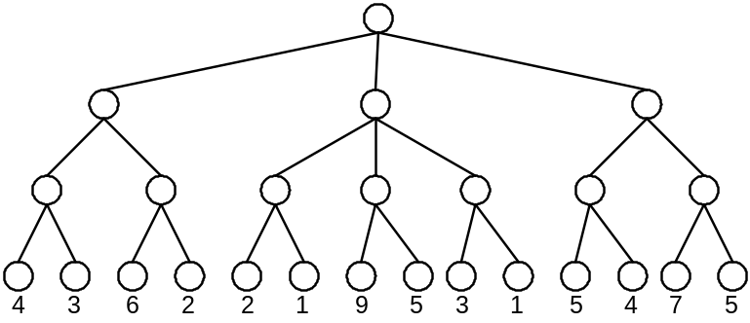
OR

Explain hill climbing local search algorithm. What are the problems associated with hill-climbing local search algorithm? Explain the solutions. 3+4+3

5. Use the following example, convert the sentences into FOL, then into CNF, and apply resolution algorithm to find the answer to the query. 3+3+4
Premises: Happy student – Anyone passing his history exams and winning the lottery is happy. But anyone who studies or a lucky can pass all his exams. John did not study but he is lucky. Anyone who is lucky wins the lottery.
Query: Is John happy?
6. i) Write Prolog source code to support following sentence using operators. 5
The wise king made good decision.
ii) Explain the destructive modification operations on lists in Lisp. 5
7. Explain A* search algorithm with a suitable example. Write short notes on variants of A* 6+4
8. Explain the steps in communication? How Natural Language Understanding architecture is used to understand the meaning of given paragraph? 5+5
9. Explain the Baye’s rules. How Baye’s rules are used for combined evidence, explain with suitable example. 4+6
10. Write short notes on any two. 5+5
i) XOR problem
ii) Backward chaining
iii) Logical equivalences

